**PROJECT – DIARY**

**Academic Year 2020-21**





(UNIVERSITY OF MUMBAI)

#### 2020-21

**GROUP DETAILS**

**Group No:** 06

**Group Members:**

1. Karthik Pillai - VU4F1718038

2. Satyam Yadav - VU4F1718040

3. Mohit Saini - VU4F1718045

#### **Project Title:** AI EYE PROGNOSTICATOR

**Project Type:** Inhouse Company **Name(if outhouse):** NA

**Internal GuideName:** Prof. Supriya Chaudhary Desai

**External Guide Name(if outhouse):**  NA

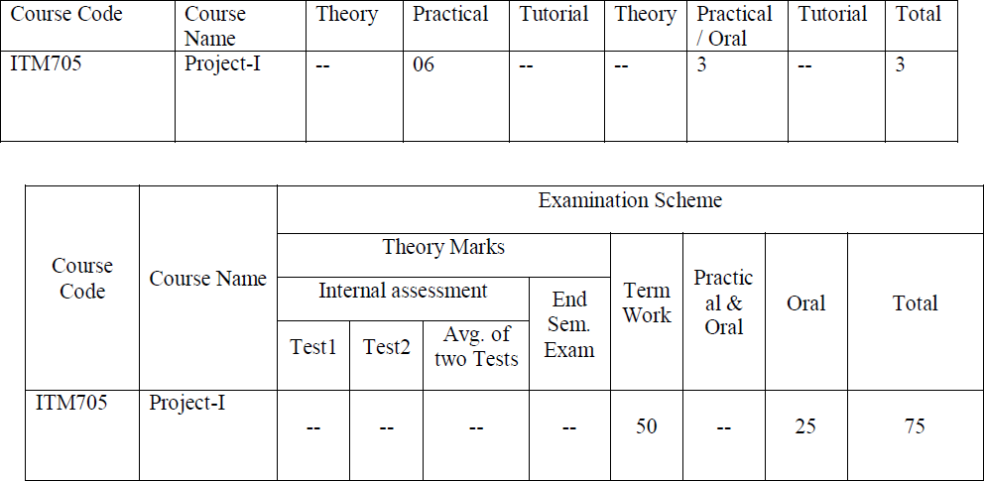

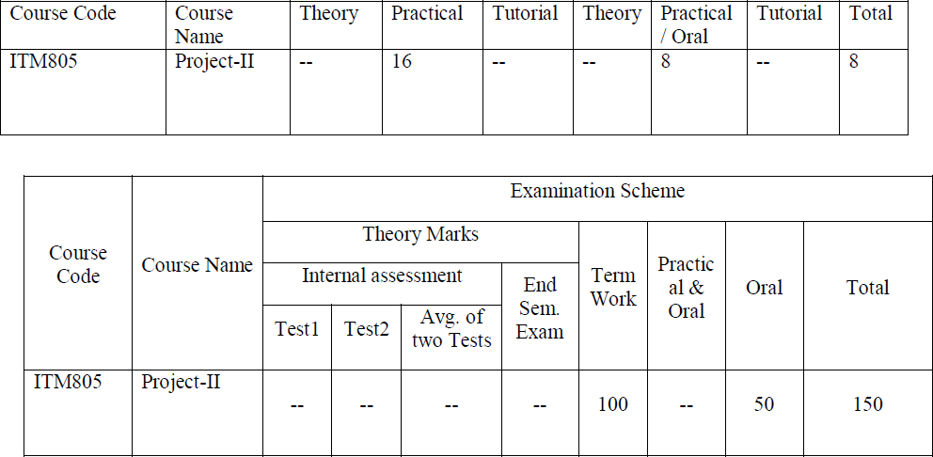

**Lab Objectives:** Students will try:

1. To offer students a glimpse into real world problems and challenges that need IT based solutions.
2. To enable students to create very precise specifications of the IT solution to bedesigned.
3. To introduce students to the vast array of literature available of the various research challenges in the field of IT
4. To create awareness among the students of the characteristics of several domain areas where IT can be effectively used.
5. To enable students to use all concepts of IT in creating a solution for problem
6. To improve the team building, communication and management skills of the students.

**Lab Outcomes:** Student will be able to:

1. Discover potential research areas in the field ofIT
2. Conduct a survey of several available literature in the preferred field of study
3. Compare and contrast the several existing solutions for research challenge
4. Demonstrate an ability to work in teams and manage the conduct of the research study.
5. Formulate and propose a plan for creating a solution for the research plan identified
6. To report and present the findings of the study conducted in the preferred domain

**Guidelines:**

1. The project work is to be conducted by a group of three students
2. Each group will be associated with a project mentor/guide. The group should meet with the project mentor/guide periodically and record of the meetings and work discussed must be documented.
3. Department has to allocate 1 day in VII semester and 2 day in VIII semester every week.
4. Students will do literature survey in Sem VI or SemVII.
5. Students will do design, implementation and coding in SemVII.
6. Each group along with its guide/mentor shall identify a potential research area/problem domain, on which the study is to be conducted.
7. Each team will do a rigorous literature survey of the problem domain by reading and understanding at least 3-5 research papers from current good quality national/international journals/conferences. (Papers selected must be indexed by Scopus/IEEE/Springer/ACM etc.). The list of papers surveyed must be clearly documented.
8. The project assessment for term work will be done at least two times at department level by giving a presentation to panel members which consist of at least three (3) members as Internal examiners (including the project guide/mentor) appointed by the Head of the department of respective Programme.
9. A report is to be prepared summarizing the findings of the literature survey. A comparative evaluation of the different techniques surveyed is also to be done.
10. Students will do testing and analyze in SemVIII
11. Teams must analyze all the results obtained by comparing with other standard techniques.
12. Every team must publish their work in national / international conferences/journals (if possible publish in Scopus indexed journals).

**Project Work**

**Progress Report**

#### Meeting Details:-

#### In the first week, finalization of group members was done. In the following week, we decided our domain and searched rigorously for suitable topics for our final year mini-project. In the next week, we eventually decided our main topic as AI EYE PROGNOSTICATOR and thereby read several research papers of IEEE related to the topic. In the fourth week, we did a literature survey that demonstrated a comparative study in chronological order of the research papers we have read. Finally, in week 5, we studied the existing systems and their advancement in the following years and also analyzed the limitations and features of those systems.

Suggestions/changes:-

No suggestions

Project Guide

(Internal)

#### Meeting Details:

#### In week 6, we prepared an abstract of our chosen topic wherein we discussed the project details, requirements, its application in future, etc. We gave valid references of the studied IEEE papers. In the meeting, we presented the literature survey, discussed the hardware and software requirements, put forth the pros and cons of the existing system and demonstrated the features of our proposed system.

Suggestions/changes:-

Choose a valid dataset for your project

Project Guide

(Internal)

#### Meeting Details:

#### Prof. Supriya Chaudhary Desai was allocated to us as a project guide. We discussed our finalized topic. They evaluated our understanding of the project by asking us several questions regarding the algorithms, challenges and dataset that we are going to use for the summarization process. We gave a brief overview of our idea for the proposed system and how we are going to overcome the limitations of the existing systems. At the end, we were allowed to continue with the topic.

Suggestions/changes:-

Topic finalized.

Project Guide

(Internal)

#### Meeting Details:

#### This week, we designed a few software system designs. Use case diagram describing how the actors can interact with the system. Data flow diagram gives a brief overview of how the data will flow in the system and what processes it will go through.

Suggestions/changes:-

Start with the implementation.

Project Guide

(Internal)

#### Meeting Details:

#### We learnt about the Google collaboration. This was helpful in simplicity and simultaneous execution on project implementation.

Suggestions/changes:-



Project Guide

(Internal)

#### Meeting Details:

#### We trained the YOLO algorithm on the COCO dataset and converted the weights to work with the TensorFlow framework.













Suggestions/changes:-



Project Guide

(Internal)

#### Meeting Details:

#### Meeting with the project guide regarding diary maintenance.













Suggestions/changes:-



Project Guide

(Internal)

#### Meeting Details:

#### Implemented program to detect humans in real-time and get the coordinates.The detection of humans from raw footage was done.

#### 















Suggestions/changes:-



Project Guide

(Internal)

#### Meeting Details: Implemented counting functionality for different labels like person, car etc. Detection of other objects like vehicles was implemented.















Suggestions/changes:-



Project Guide

(Internal)

#### Meeting Details:

#### Implemented code to find the direction of motion of human/car. Thus whether the person or vehicle is in an incoming or outgoing direction is determined.















Suggestions/changes:-



Project Guide

(Internal)

#### Meeting Details:

#### Implemented social distance measuring functionality by measuring distance between centers of bounding boxes.

#### Added object tracker using deepsort algorithm. This feature is used to track the moving path of the object. It uses a queue for each object.















Suggestions/changes:-



Project Guide

(Internal)

#### Meeting Details:

#### Implemented bidirectional counter for counting vehicles on highways. Using a bidirectional counter, the number of vehicles incoming or outgoing in raw footage was counted.















Suggestions/changes:-



Project Guide

(Internal)

#### Meeting Details:

#### Project review 1. Ma'am asked to find out the specific application for the project.















Suggestions/changes:-



Project Guide

(Internal)

#### Meeting Details:

#### As suggested by our project guide. We started looking for a specific application of our project. We studied various IEEE papers and revisited our literature survey to find the appropriate applications for our project.















Suggestions/changes:-



Project Guide

(Internal)

#### Meeting Details:

#### The Powerpoint presentation (PPT) for the project AI Eye Prognosticator was prepared.















Suggestions/changes:-



Project Guide

(Internal)

#### Meeting Details:

#### The Report for the project AI Eye Prognosticator was prepared.















Suggestions/changes:-



Project Guide

(Internal)

#### Meeting Details:

#### Project review 2 was done.















Suggestions/changes:-



Project Guide

(Internal)

#### Meeting Details:



Added TAIL TRACKING feature to the existing work.











Suggestions/changes:-



Project Guide

(Internal)

#### Meeting Details:

Extended TAIL TRACKING feature to create HEATMAP and export as Image.













Suggestions/changes:-



Project Guide

(Internal)

#### Meeting Details:



Linked the incoming outgoing feature with the database to store large amount of data for creating graphs.











Suggestions/changes:-



Project Guide

(Internal)

#### Meeting Details:



Started to develop a web interface for analysis.









Suggestions/changes:-



Project Guide

(Internal)

#### Meeting Details:



Created insightful graphs for hourly visual statistics









Suggestions/changes:-



Project Guide

(Internal)

#### Meeting Details:



Created insightful graphs for monthly visual statistics









Suggestions/changes:-



Project Guide

(Internal)

#### Meeting Details:



Created insightful graphs for yearly visual statistics







Suggestions/changes:-



Project Guide

(Internal)

#### Meeting Details:



Started paper creation for paper publication. Paper published on IRJET.













Suggestions/changes:-



Project Guide

(Internal)

#### Meeting Details:



Project Review 3 was conducted by the Professor and all the concerned fields were addressed.









Suggestions/changes:- The project is ready for the final submission.



Project Guide

(Internal)

**Project Evaluation**

Group No: 06 Topic Name: AI Eye Prognosticator

|  |  |  |  |  |
| --- | --- | --- | --- | --- |
| **Sr No** | **SEM** | **REVIEW NO** | **DATE** | **COMMITTEE MEMBERS** |
| 1 | VII | 1 | 04-11-2020 | Guide name: Prof. Supriya Chaudhary Desai  Internal examiner 1:  Internal examiner 2: |
| 2 | VII | 2 | 06-01-2021 | Guide name: Prof. Supriya Chaudhary Desai  Internal examiner 1:  Internal examiner 2: |
| 3 | VIII | 3 | 15-03-2021 | Guide name: Prof. Supriya Chaudhary Desai  Internal examiner 1:  Internal examiner 2: |
| 4 | VIII | 4 |  | Guide name: Prof. Supriya Chaudhary Desai  Internal examiner 1:  Internal examiner 2: |

Name of Guide: Prof. Supriya Chaudhary Desai

Name of Project Coordinator: Prof. Vijaya Bijoor

Name of HOD IT: Prof. Seema Lade